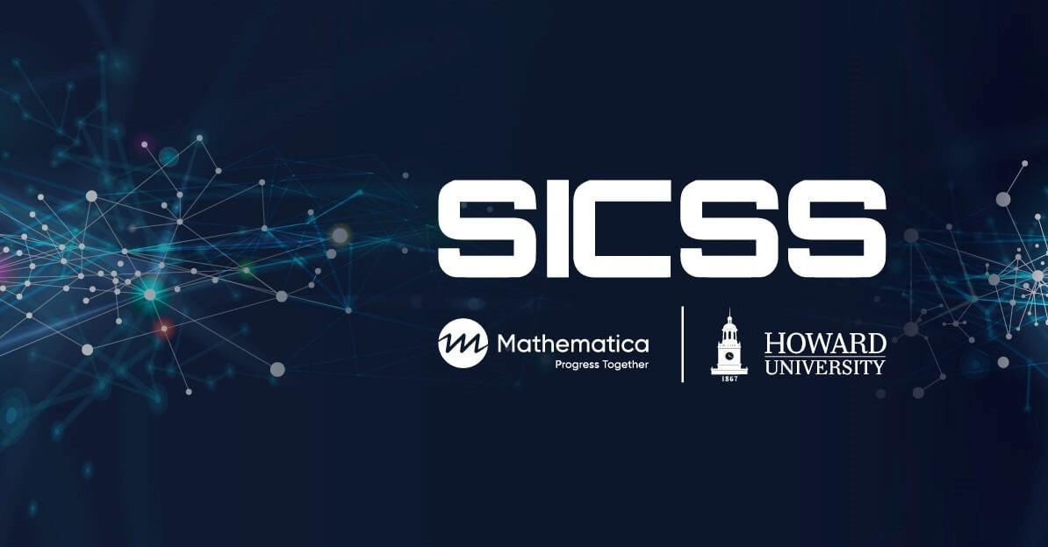

# **Participants Instructions**

## **Day 4: Non-Probability-Based Surveys in Practice**

## **Updated by Naniette H. Coleman; Prepared by Lai Wei and Matt Salganik**

Please read the entire lesson plan before beginning.

## **Summary**

How accurate are estimates from non-probability-based online surveys? In this activity, you will design a questionnaire, deploy it to Amazon Mechanical Turk (or some similar platform), produce unweighted and weighted estimates, and then compare your estimates to those that come from high-quality probability-based sample. This activity was inspired by a paper written by Sharad Goel, Adam Obeng, and David Rothschild: [Online, Opt-in Surveys: Fast and Cheap, but are they Accurate?](https://5harad.com/papers/dirtysurveys.pdf) The survey that you will partially replicate was done by the [Pew Research Center](https://www.pewresearch.org/) about [policy priorities](https://www.pewresearch.org/politics/2021/01/28/economy-and-covid-19-top-the-publics-policy-agenda-for-2021/) and [social media use](https://www.pewresearch.org/internet/2021/04/07/social-media-use-in-2021/).

### **Learning objectives**

Participants will gain experience with the following activities:

* Reading survey results and methodology reports
* Creating questionnaires on Google forms. [Note: This assignment uses Google Forms because it is free and widely available. See the end of this lesson plan for comments about using [Qualtrics](https://www.qualtrics.com/), a more sophisticated platform that requires payment or institutional support that not everyone has access to.]
* Deploying jobs to Amazon Mechanical Turk (or some similar platform)
* Data wrangling and survey weighting
* Using the total survey error framework to reason about and discuss sources of errors in estimates

### **Before group activity**

* Read [Chapter 3 in *Bit by Bit*](https://www.bitbybitbook.com/en/1st-ed/asking-questions/)
* Read the [Mathematical notes in Chapter 3 in *Bit by Bit*](https://www.bitbybitbook.com/en/1st-ed/asking-questions/sampling-mathematical/)
* Read the paper that motivated this activity: [Online, Opt-in Surveys: Fast and Cheap, but are they Accurate?](https://5harad.com/papers/dirtysurveys.pdf) by Goel et al.
* Read [Intro to Poststratification](https://github.com/compsocialscience/summer-institute/blob/master/2021/materials/day4-surveys/activity/introduction_to_poststratificiation.md)

### **Activity schedule**

* 2 hour and 45 minutes
  + 1 hour in the morning: prepare and deploy surveys
  + break for lunch while data is being collected on MTurk
  + 1 hour and 45 minutes in the afternoon
    - 15 minutes: validate survey responses and pay MTurk participants
    - 60 minutes: analyze a larger dataset that we collected for you
    - 30 minutes: discuss activity

## **During group activity**

### **Morning session:**

* Create a questionnaire on Google Forms. When you are done, your questionnaire will look a bit like [this one](https://docs.google.com/forms/d/e/1FAIpQLSdVeXuX9qRfDW57alR0ySEDPHTiUz7wuwDzioa-YxQs485fHg/viewform?usp=sf_link) (30 minutes).
* Start by reviewing the existing questionnaire (click “I disagree” to the first question to run it in test mode). You will need to rebuild the survey for your team. Make sure you include a consent statement, attention check questions, and questions about demographics.
* Add your contact information to the consent statement.
* Populate your survey with questions from the [Pew Research Center](https://www.pewresearch.org/) about [policy priorities](https://www.pewresearch.org/politics/2021/01/28/economy-and-covid-19-top-the-publics-policy-agenda-for-2021/) and [social media use](https://www.pewresearch.org/internet/2021/04/07/social-media-use-in-2021/).
* Add at least one complementary module on an anti-Black racism or inequity topic of your choosing. These questions do not need to come from the [Pew Research Center](https://www.pewresearch.org/).
* Within your group, pilot test your new questionnaire and confirm that it can be completed within 7 minutes.
* Deploy your survey to Amazon Mechanical Turk (30 minutes).
* You will request a task as "Survey Link".
* [Here](https://blog.mturk.com/tutorial-getting-great-survey-results-from-mturk-and-google-forms-da4993d878df) is a blog post tutorial on how to deploy Google Forms questionnaire on MTurk.
* We estimate that the survey will take about 7 minutes, and we would like to pay an hourly wage of $15 per hour so you should pay $1.75 per completed survey. When figuring out how many responses you want to collect, please factor in the [MTurk fee](https://www.mturk.com/pricing).
* For participants at SICSS-Howard-Mathematica: We have a solution for possible lack of MTurk accounts by our participants. Please create your survey and go to office hours to deploy. Bring the following information with you:

1. Study URL
2. Number of participants requested
3. Study title (will be displayed to participants)
4. Study description (also displayed, 1-2 sentences)
5. Payment per survey
6. Estimated time to complete (in minutes)
7. Hit approval rate of participants (recommended default is >95%)
8. Number of previous HITs approved (not so important, can skip if this is a distraction)
9. Whether the HIT should be targeted to a specific census region or left to all US participants

### **Afternoon session:**

* After the data has been collected, validate the survey and pay MTurk workers (15 minutes).
  + Download the CSV of responses from Google Forms.
  + Check to make sure that all of your MTurk workers actually took the survey by comparing the list of Worker IDs provided in the survey data against the Worker IDs recorded by the MTurk platform. [1]
  + Delete responses that did not meet the attention check criteria.
  + Pay MTurk workers that completed surveys. When in doubt about whether to pay or not, please err on the side of paying the workers.
  + Remove redundant entries, if any.
  + After you have used the Worker ID data to validate answers and to remove redundant entries, delete it from your dataset. The Worker ID is a unique string that can be used to personally identify people.
* Analyze the data we previously collected (60 minutes).
  + Cost constraints mean that each group can only collect a small number of responses. Therefore, we have pre-collected one large dataset that all the groups can analyze. Note that for the political priority questions which have four potential answers, we have transformed the answers into binary in our data cleaning step where we coded "TOP PRIORITY" as "1" and all other responses as "0". Download the data that we collected with this [questionnaire](https://docs.google.com/forms/d/e/1FAIpQLSdVeXuX9qRfDW57alR0ySEDPHTiUz7wuwDzioa-YxQs485fHg/viewform?usp=sf_link) from MTurk workers [here](https://github.com/compsocialscience/summer-institute/blob/master/2021/materials/day4-surveys/activity/2021_clean_mturk_data.csv).
  + Compare the raw (unweighted) estimates to the [results found by Pew](https://github.com/compsocialscience/summer-institute/blob/master/2021/materials/day4-surveys/activity/pew_benchmark_2021.csv) [2]. Next compare the estimates after doing [cell-based post-stratification](https://github.com/compsocialscience/summer-institute/blob/master/2021/materials/day4-surveys/activity/introduction_to_poststratificiation.md). Use [this template](https://github.com/compsocialscience/summer-institute/blob/master/2021/materials/day4-surveys/activity/survey_activity_2021_template.Rmd) as you work through these steps. The template will help you replicate Figures 1 and 2 from Goel et al. and avoid some common pitfalls.
  + Due to the time constraint, you won't be able to do techniques as complicated in the paper by Goel et al. However, those sections are marked as optional extensions in the template code, and we provide the instructions on how to do them in the code [here](https://github.com/compsocialscience/summer-institute/blob/master/2021/materials/day4-surveys/activity/survey_activity_2021_solution.Rmd).

## **Additional resources**

* [Here](https://psrc.princeton.edu/our-services/using-mturk) are some more resources on web surveys and [here](https://mturkpublic.s3.amazonaws.com/docs/MTURK_BP.pdf) is Amazon's best practices for MTurk Requesters.
* Zallot et al. [“Crowdsourcing in Observational and Experimental Research”](https://www.routledgehandbooks.com/doi/10.4324/9781003025245-12)
* Dutwin and Buskirk. ["Apples to Oranges or Gala versus Golden Delicious?: Comparing Data Quality of Nonprobability Internet Samples to Low Response Rate Probability Samples"](https://academic.oup.com/poq/article/81/S1/213/3749202/Apples-to-Oranges-or-Gala-versus-Golden-Delicious)
* Baker et al. ["Summary Report of the AAPOR Task Force on Non-probability Sampling"](https://academic.oup.com/jssam/article/1/2/90/941418/Summary-Report-of-the-AAPOR-Task-Force-on-Non)
* Kalton and Flores-Cervantes ["Weighting methods"](http://www.jos.nu/Articles/abstract.asp?article=192081)
* Berinsky, Margolis, and Sances ["Separating the Shirkers from the Workers? Making Sure Respondents Pay Attention on Self‐Administered Surveys"](https://doi.org/10.1111/ajps.12081)
* [Target Estimation and Adjustment Weighting for Survey Nonresponse and Sampling Bias](https://www.cambridge.org/core/books/target-estimation-and-adjustment-weighting-for-survey-nonresponse-and-sampling-bias/B28F1B4CC17B42D513EC3E0356926C23)
* [Pewmethods R package](https://github.com/pewresearch/pewmethods)
* An alternative to Amazon Mechanical Turk is [Prolific](https://www.prolific.co/)

## **Appendix: Qualtrics-specific instructions**

* If you are using Qualtrics instead of Google Forms, you do not have to include a question on the survey asking for MTurk Worker ID. Instead, you can verify survey completion by generating a unique validation code for each survey respondent, and have them enter that on MTurk instead.
* Here are [detailed instructions](https://blog.mturk.com/getting-great-survey-results-from-mturk-and-qualtrics-be1704ff9786) for generating survey completion codes.
* Qualtrics has more features and customizable options -- for example, you can randomize the response options to a survey question or enable more sophisticated skip logic. Try playing around with these!

### **Acknowledgments**

The updated version of this activity was conceptualized and created at the SICSS-Howard/Mathematica site in 2022 with the goal of our participants and all SICSS participants having the option to do exercises that allow them to directly engage the topics of anti-Black racism and inequity alongside learning about Computational Social Science. This exercise would not have been possible without support from Chris Bail, Matt Salganik, Akira Bell, Jesse Chandler, Joshua Dyck, and Amber Du, Alina Gu, Amanda Lee, Ava Wu, and the entire Coleman Research Lab at the University of California Berkeley. The original activity was designed with input from participants and TAs from SICSS 2017-2020, especially Yo-Yo Chen, Janet Xu, Simone Zhang, Robin Lee, and Ian Lundberg.

## 

## 

## 

## **Footnotes**

[1] Tip: to validate WorkerID matches, you can download a CSV of WorkerIDs from your MTurk results page and match that with your survey results data.

[2]Technical note: Most survey questions have a "don't know/refuse" residual category, but predicting the percentage of people who refused to answer may not always be substantively relevant. To omit this category from the analysis, we normalized the existing survey results by dividing by the percentage of people who responded to that question.